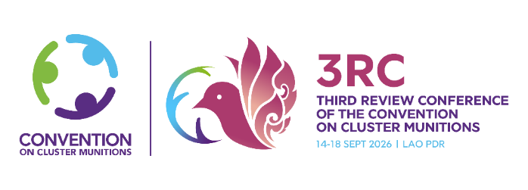 | Implementation Support Unit of the  Convention on Cluster Munitions (ISU CCM)  Maison de la Paix | Tower 3 | 8th Floor  Chemin Eugène-Rigot 2C | 1202 Geneva  Switzerland  t. +41 (0) 22 730 9761 / 9304 / 9314  info@cmconvention.org | www.clusterconvention.org  Follow us on X | Like us on Facebook | Subscribe to us on YouTube

Second Preparatory Meeting of the Third Review Conference of
States Parties to the Convention on Cluster Munitions

Geneva, 1 July 2026

SIDE EVENT REQUEST FORM

This form needs to be completed and submitted by Thursday, 25 June 2026
via email to info@cmconvention.org with ccm@un.org in copy.

- GENERAL INFORMATION

Title of the event: _________________________________________________________________________
Date: 1 July 2026

Mode (online / in-person / hybrid): _________________________________

Please note that the side event rooms are only available between 13:00 and 15:00 hours.

Organizer(s)
Name of the Organization(s) and/or State(s): __________________________________________________________________________________________________________________________________________________________________________________

Person in charge: _______________________________________________________________________

Address of the organizer(s):
__________________________________________________________________________________________________________________________________________________________________________________
_________________________________________________________________________________________

Phone number: ______________________________________________________________

Contact email: ______________________________________________________________

Brief Description:
Provide a concise summary of the proposed side event. The description should include, but not limited to the following elements: a) Objective of the discussion; b) Key topics or theme to be addressed; c) Events’ relevance to the purpose and implementation of the Convention.
___________________________________________________________________________________________________________________________________________________________________________________________________________________________________________________________________________
_______________________________________________________________________________________________________________________________________________________________________________________________________________________________________________________________________________________________________________________________________________________________________________________________________________________________________________________________________________________________________________________________________________________________________________________________________________________________________________

- SIDE EVENT ROOM INFORMATION

With regard to the venue of the proposed side event, H207/208/209 is available for side events.

For more information regarding the capacity of the above-mentioned room, including available services and location on the grounds of the Palais des Nations, please refer to the Brochure of Conference Rooms prepared by UNOG.

Please mention any special requirements below:
____________________________________________________________________________________________________________________________________________________________________________________________________________________________________________________________________________________________________________________________________________________________________

Format: Panel/Roundtable /Presentation

Kindly provide below the names of the panelists as well as their State/Organization:

Moderator
Name: _____________________________

Panelist 1
Name: _____________________________
State/Organization: _____________________________________________________

Panelist 2
Name: _____________________________
State/Organization: _____________________________________________________

Panelist 3
Name: _____________________________
State/Organization: _____________________________________________________

Panelist 4
Name: _____________________________
State/Organization: _____________________________________________________

Additional Panelists:
__________________________________________________________________________________________________________________________________________________________________________________

- CATERING INFORMATION

If you would like to arrange catering for your event, please contact UNOG’s catering service Eldora directly for assistance at onu@eldora.ch

- SIDE EVENT PROMOTION

Information on the event:

Event and/or registration link(s):

Flyers
Any flyers you might want included on the meeting webpage should be received by Wednesday, 24 June 2026.

Please note that your request will be confirmed at a later date by the CCM ISU, taking into account room availability and other scheduling considerations.

