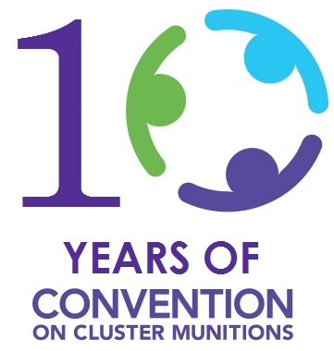 | QUARTERLY  NEWSLETTER
2018 2nd Quarter
Highlights
(1st April – 30 June)
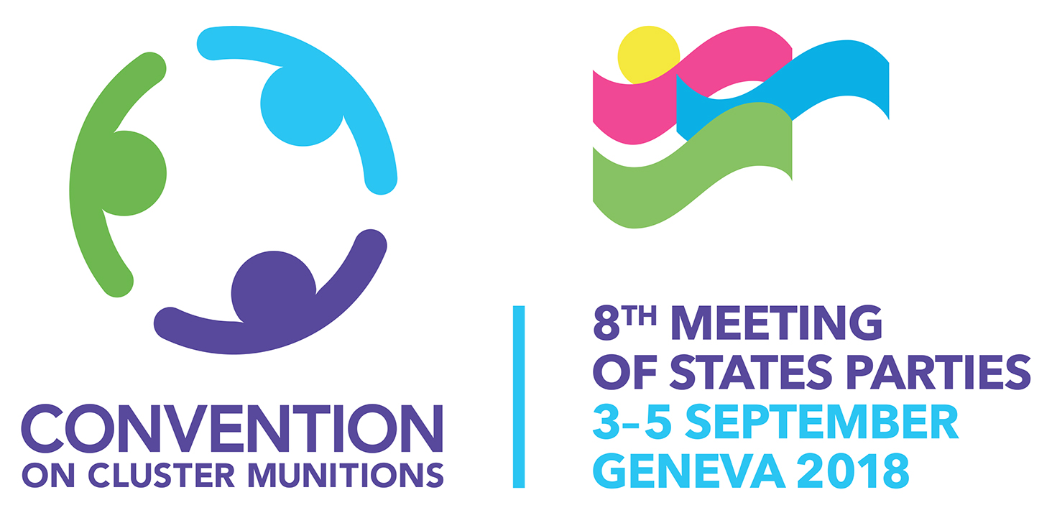
8MSP Registration
The Eighth Meeting of States Parties (8MSP) to the Convention on Cluster Munitions will take place from 3-5 September 2018 in Room XVIII at the Palais des Nations in Geneva, Switzerland. The details of delegations to the 8MSP should be submitted via Note Verbale by Friday, 17 August 2018, to the Secretary of the Eighth Meeting of States Parties to the Convention, at the following email address: ccm@un.org
8MSP Conference Documents
The Meeting’s Provisional Agenda (CCM/MSP/2018/1) and the Implementation Support Unit’s 2019 Work Plan and Budget (CCM/MSP/2018/2) are now available on the UNOG and the Convention’s websites: https://bit.ly/2K0PZys or http://www.clusterconvention.org/8msp/. Both websites will be regularly updated with additional documents and information as the meeting approaches.
Highlights from 8MSP Provisional Agenda
Candidates for future CCM Presidencies
Two States Parties have submitted their candidacies to serve as the presidents of forthcoming CCM Meetings of States Parties. Newest State Party, Sri Lanka, submitted its candidacy to preside over the Ninth Meeting of States Parties (9MSP) to be held in 2019, while Switzerland has offered to preside over the Second Review Conference (2RC) of the CCM scheduled for 2020.
Determination of CCM presidencies is currently on a voluntary basis. In order to ensure a troika of presidencies exists (immediate past, incumbent and president designate) within the Convention’s machinery, an agenda item has been included for discussion at the 8MSP to deliberate how best this arrangement could be established and sustained. The aim is to further enhance the smooth handover of functions between presidencies, to establish predictability and to better balance regional and gender representation in leading implementation of the Convention.
Guidelines for CCM Article 3 and Article 4 Extension Requests

With the first Treaty deadlines coming up soon for Articles 3 and 4, draft Guidelines for CCM Article 3 and Article 4 extension requests have been prepared and will be presented for consideration at the 8MSP. The documents will be made available on the UNOG and the Convention’s website well ahead of the Meeting.

Informal Meeting on Enhancing International Cooperation and Assistance (Article 6)

On Friday 8 June 2018, Australia and Peru, CCM Coordinators on International Cooperation and Assistance, hosted an informal meeting in the margins of the 2018 Anti-Personnel Mine Ban Convention (APMBC) Meeting Intersessional Meetings.

In addition to the Coordinators and representatives of the Implementation Support Unit (ISU), approximately 16 representatives - 10 from potential donor/partner states and six from States with needs under the CCM - participated in the meeting. Participants discussed current reported cooperation and assistance needs and capacities, key points raised in informal meetings held on 24 November and 20 December 2017, and progress and next steps in operationalising the “Country Coalitions” developed by the Presidency of the Seventh Meeting of States Parties (7MSP) which seeks to promote tailor-made partnerships and strategies to implement the CCM.
Transparency Measures (Article 7)
As at 30 June 2018, 13 States Parties had overdue Initial Transparency Reports – two of these were expected from two new States Parties with deadlines due in the quarter under review. Additionally, 26 States Parties had also missed the 30 April 2018 deadline for the submission of their 2017 Annual Transparency Report. States Parties are reminded of the importance of the annual reporting obligation and encouraged to comply with their Article 7 obligations as quality and timely reporting by States Parties is essential in allowing for the effective monitoring of progress in the implementation of the Convention, the exploration of solutions to challenges faced, and, where possible, the creation of partnerships to expedite this implementation.

Contact details
Implementation Support Unit of the Cluster Convention Munitions (ISU-CCM)
Chemin Eugène-Rigot 2C, 1211 Geneva, Switzerland
info@clusterconvention.org
See more at: www.clusterconvention.org

