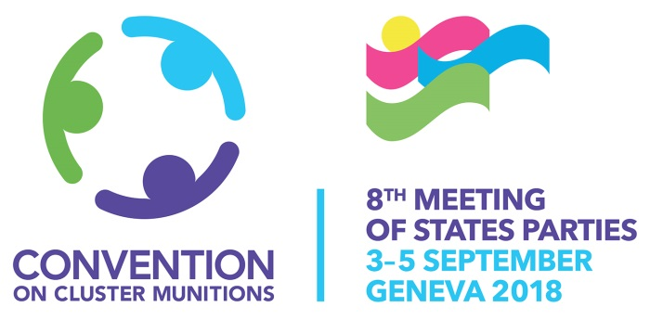

SIDE EVENT ROOM REQUEST FORM

This form has to be filled out and submitted before Friday 17 August 2018
by e-mail to info@cmconvention.org with a copy to ccm@un.org

- GENERAL INFORMATION

Title of the event: ____________________________________________________________
Date of the event: ____ September 2018

Time: __:__ - __:__

Number of participants: _____________expected

Organizer(s)
Name of the company, organization or permanent mission: ______________________________________________________________________________________________________________________________________________________

Person in charge ____________________________________________________________

Address of the organizer(s):
______________________________________________________________________________________________________________________________________________________
___________________________________________________________________________

Phone and fax numbers:
______________________________________________________________________________________________________________________________________________________

E-mail: _____________________________________________________________________

- SIDE EVENT ROOM INFORMATION

Seating requested

We have 2 rooms blocked for the side events:
Side events room 1 – ROOM XXIV - Palais des Nations = max 260 pax
Side events room 2 – ROOM XXV - Palais des Nations = max 130 pax

Please mention any special needs below:
______________________________________________________________________________________________________________________________________________________

Equipment requested

Please indicate the type of equipment required (PowerPoint projector, flip charts, etc.). Please note that laptops will not be provided

______________________________________________________________________________________________________________________________________________________

Panel

Kindly provide below the number of panelists as well as their full name & State / Organization

Panelist 1
Name: _____________________________
State/Organization: _____________________________________________________

Panelist 2
Name: _____________________________
State/Organization: _____________________________________________________

Panelist 3
Name: _____________________________
State/Organization: _____________________________________________________

Panelist 4
Name: _____________________________
State/Organization: _____________________________________________________

Any additional Panelists
_________________________________________________________________________________________________________________________________________________________________________________________________________________________________

- CATERING INFORMATION

The catering will be provided by the UN Cafeteria and set on a buffet outside the side events room. Kindly contact them directly at the following: http://www.myplanetfood.ch/en/the-cafeterias/unog-main-cafeteria/introduction/

- SIDE EVENT FLYERS

Any flyers you might want included in the Conference delegate Welcome Kit should be received by Friday 24 August 2018. Please limit to maximum of 1 x A4 paper size.

Any Additional Details / Information:
____________________________________________________________________________________________________________________________________________________________________________________________________________________________________________________________________________________________________________

Note that your request will be confirmed later by the 8MSP Team depending on room availability and other scheduling considerations.

